**6.0 SYSTEM DESIGN SPECIFICATION**

**6.1 Architectural Design**

The content of an architectural design is a model that delineates its views, behavior and structure as a system. It is basically a formal representation of the system which is supported by reasons of its performances and constructions of the system.

**Context Diagram**

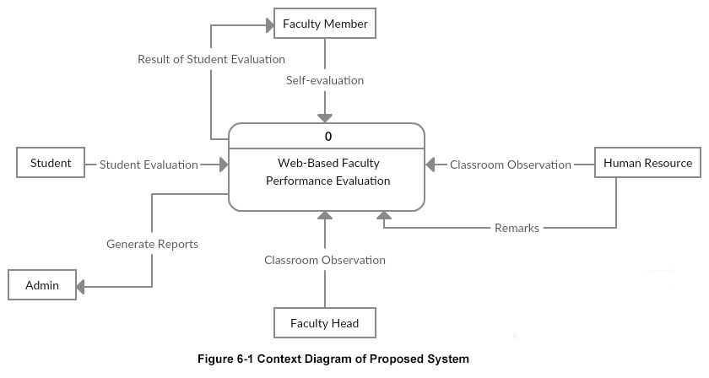

Figure 6-1 shows the overview of the proposed system. The Web-Based Faculty Performance Evaluation on Teaching Effectiveness has five entities, the Student, Faculty Member, Faculty Head, Human Resource and Administrator.

**Level 0 Data Flow Diagram**

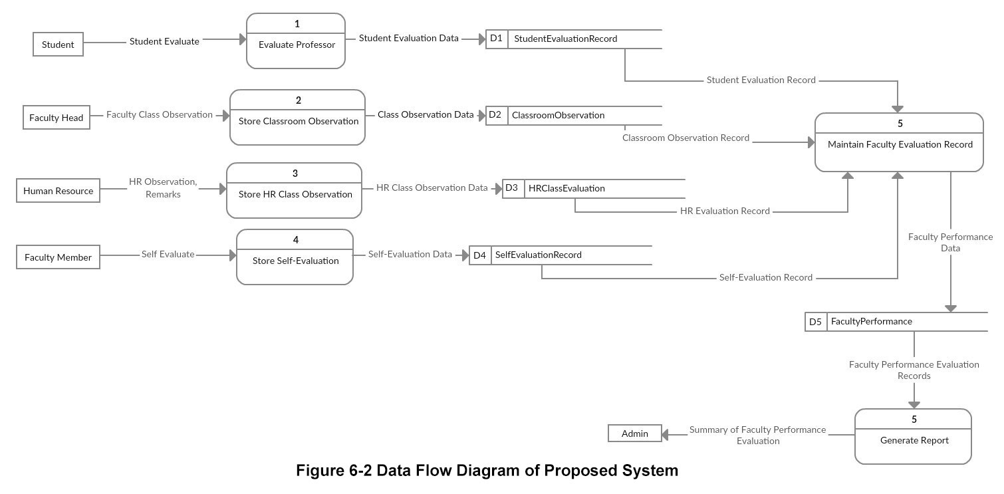

Figure 6-2 shows the Level 0 Data Flow Diagram of the system. The student will evaluate their professor to measure teaching effectiveness and ensure high quality learning experiences. Faculty Heads will rate the faculty members’ classroom performance using laptop or mobile devices online. Also, the Human Resource Director will also rate the faculty members’ classroom performance and provide some feedbacks/remarks using laptop or mobile devices online. Faculty Member will also take self-evaluation to rate themselves thoughtfully for the performance they made. The data of all the entities evaluation will be stored in a process to produce a faculty performance evaluation records, to come up and to generate reports of summary faculty performance evaluation that will be given to Admin.

**6.1.1 Database Tables**

**Table 6-1: FacultyPerformanceEvaluation**

*FacultyPerformanceID

FacultyID

StudentEvalID

SelfEvalID

ClassroomID

**Table 6-2: Student**

*StudentNo.

LastName

FirstName

CourseID

**Table 6-3: Faculty**

*FacultyID

LastName

FirstName

Department

**Table 6-4: Course**

*CourseID

Course

Section

**Table 6-5: StudentEvaluation**

*StudentEvalID

StudentNo

SubjectCode

**Table 6-6: SelfEvaluation**

*SelfEvalID

FacultyID

**Table 6-7: ClassroomObservation**

**\***ClassroomID

FacultyID

SubjectCode

**Table 6-8: Subject**

*SubjectCode

SubjectDesc

**Table 6-9: User**

*UserID

Code

**6.2 System Functions**

Login Interface – On this login interface, the Students, Faculty Heads, Faculty Members, Human Resource Director and Administrator will log into the system using their ID no. and code.

Student Evaluation Interface – Once the student logs in, they will see their respective professors’ subject handle, course and section. Students can choose which professors will they evaluate first by clicking the dropdown button and they can put comments regarding on their professors performance.

Faculty Head Interface – Once faculty heads log in, they will see a Data Entry asking to input a Faculty Members’ name under their Department.

Classroom Observation Interface – After inputting a Faculty Member’s name and clicking the Submit button, Faculty Head can now rate the Faculty’s Class Performance and add remarks on the faculty’s performance.

Faculty Member Interface – Once faculty members log in, they will see two categories which are the subject handle button and self-evaluation button.

Faculty Member: Student Result – Once they click the subject handle button, they can choose what subject (their load for this semester) they want to see the student evaluation results.

Faculty Member: Self-Evaluation – Once they click the self-evaluation button, Faculty Member can now self-evaluate themselves.

Human Resource Interface – Once faculty heads log in, they will see a Data Entry asking to input a Faculty Members’ name.

HR Classroom Observation Interface – After inputting a Faculty Member’s name and clicking the Submit button, HR Director can now rate the Faculty’s Class Performance and add remarks on the faculty’s performance.

Administrator Interface - Once the admin logs in, they will see a category of Student Evaluation, Faculty Head Classroom Observation and HR Classroom Observation.